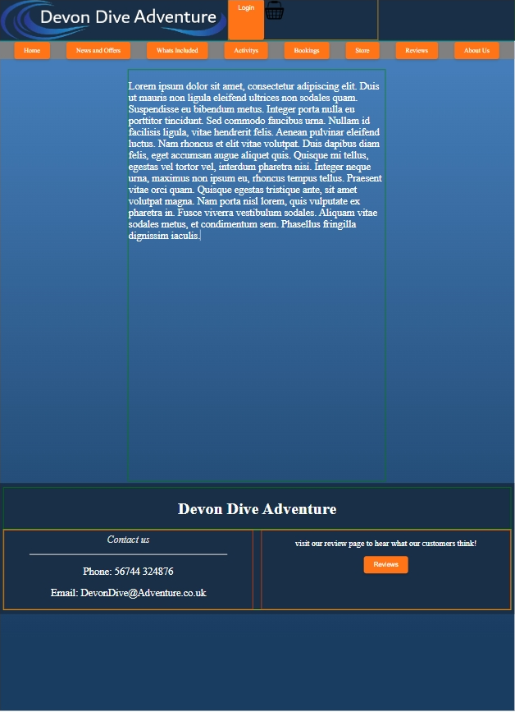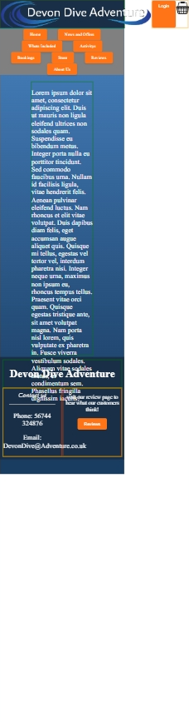
No 1: Screen aria wont resise properly so making objects in line and felx then make the dividers shrink when resizing screen.

No 2:
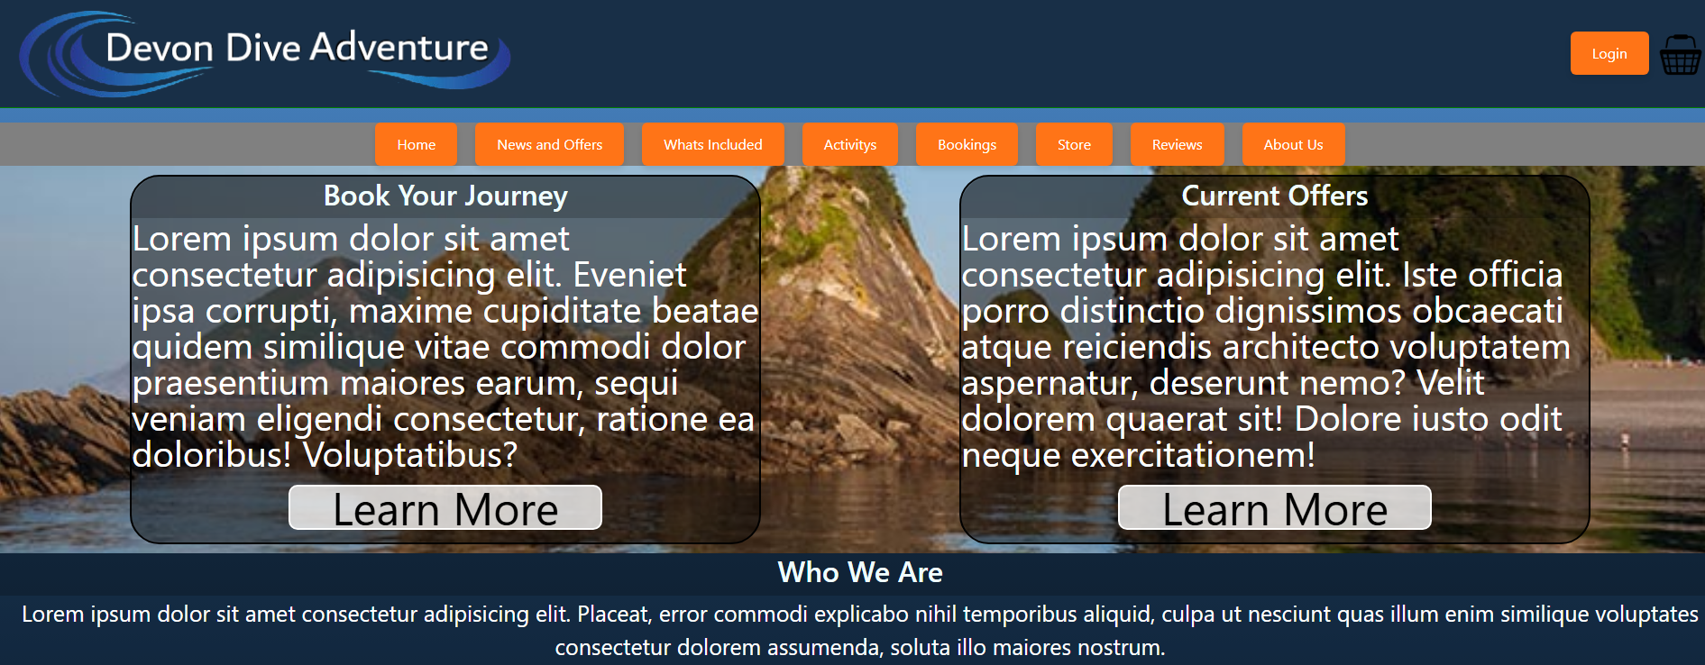
Weird blue line between the banner and the nav bar
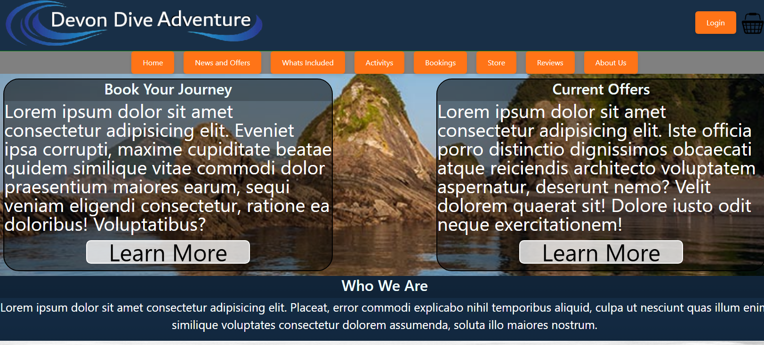
There was an extra div that was not needed

No 3: Images were all loading at a small size because to create the logo at a small side we changed the img tag propertys where as we should have used classes to make it so it didn’t change it for all images.

No 4

